Bellwork 2016-2017

Bellwork #1
List 3 things I should know about you.
1 should pertain to your hobbies, interests, family, etc.
1 should pertain to your learning habits, and how I can be a better teacher for you.
1 should be something that will help me remember you.
Explain each item to create a paragraph.

Bellwork #2
Write the same sentence in 1st, 2nd, and 3rd person.

Bellwork #3
Write a paragraph about what makes you nervous about writing a short story. OR what makes you excited. Within this paragraph please list at least 3 things you would like for me to go over that you think will help you with the writing process.

Bellwork #4
Free Write Friday! 1 page min.
(If you would rather work on your story instead that’s fine with me!!)

Bellwork #5
Motivational Monday!

Bellwork #6
Test out 3 opening lines on your tablemates. Write a paragraph about their feedback.

Bellwork #7
Free Write Friday! 1 paragraph only!

Bellwork #8
Motivational Monday!
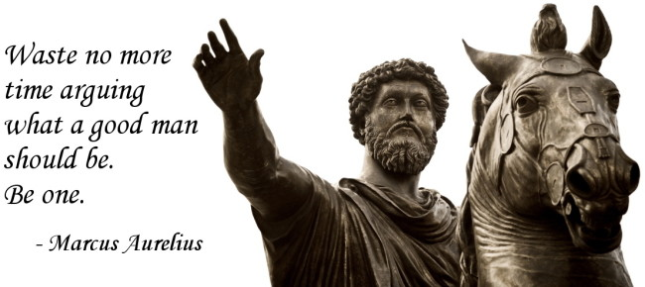

Bellwork #9
Discuss the plot of your story with either your shoulder or face partner. Write down the basic plot of THEIR story, and 3 questions you still have for them. If they have a part of their draft they would like to share with you, read that as well before writing your questions.

Bellwork #10
What is the theme of your story? List 3 plot events that help to develop your theme.

Bellwork #11 BELLWORK CHECKS TODAY!! 1-10
The following infographic shows problems that children face at home other than simple chores or homework. It also displays how many of those children also have or have had a parent incarcerated. Please respond to the infographic in 1 paragraph minimum.
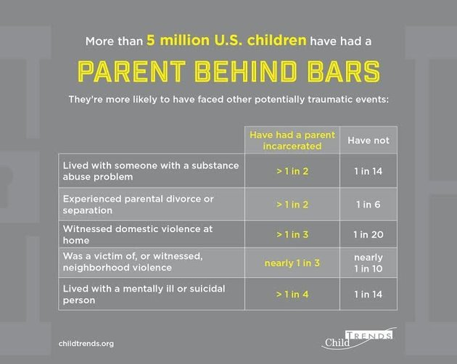 | -How do these situations impact a child’s future?  -How do they impact their school work?  -What can be done to improve these situations?

Bellwork #12
Motivational Monday!
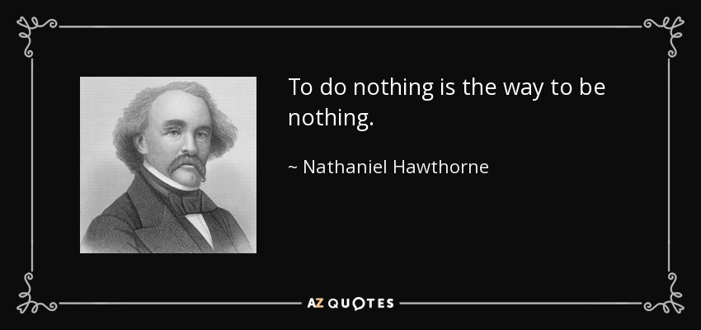
Bellwork #13
Put To, Too, or Two in each blank.
1. She wanted ____ go ____ bed early.
2. It's ____ wet ____ sit on the grass.
3. He was ____ drunk ____ stand up.
4. He only had ____ minutes ____ answer the question.
5. ____ go by train will be ____ expensive.
6. He had ____ catch ____ buses ____ go ____ work.
7. No one is ____ old ____ learn.
8. His ____ friends helped him ____ move home.
9. She had ____ take her little sister ____.
10. She was ____ young ____ join the army.

Bellwork #14
What did your grades look like at the end of the first 9 weeks? As we approach mid-term of the second 9 weeks, what do you hope your grades look like this time? What are you doing to maintain/improve your grades from the first 9 weeks?

Bellwork #15
List 5 things you can look at to improve your paper before you turn it in today.

Bellwork #16
Free Write Friday!
1 page minimum

Take an AR test now if you need to!
Share your Google Doc with me!

Bellwork #17
Motivational Monday!
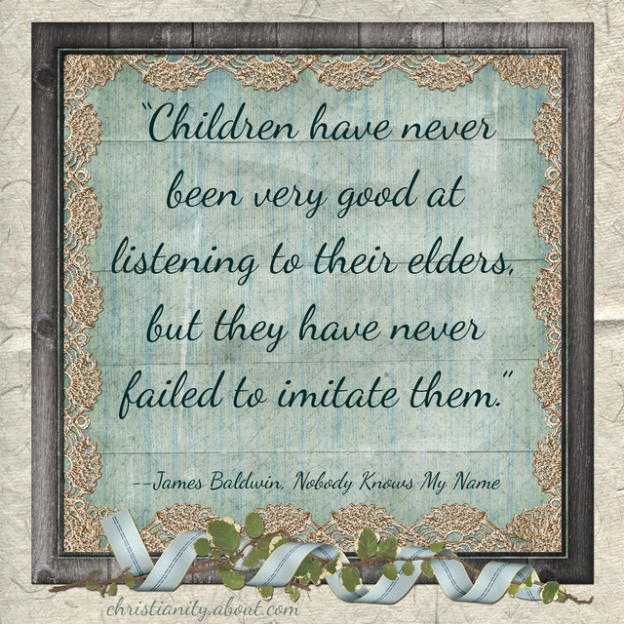

Bellwork #18
What is the overall text structure of the Rotten Apple article? What other, smaller structures can be found throughout? Explain your thinking.
- You may get a magazine if you need one.

Bellwork #19
Tomorrow is Veteran’s Day. What does Veteran’s Day mean to you? 1 paragraph min.

Bellwork #20
Free Write Friday! 1 page minimum.
Bellwork Checks today!
***11-19***
Bellwork #21
Motivational Monday!
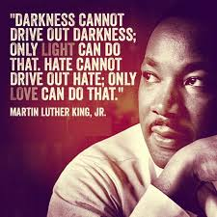

Bellwork #22
What is an inference?

Bellwork #23
How can things like Text Features, Text Structures, Central Idea, and Inferences help you to analyze an Informational Text? 1 paragraph min.

Bellwork #24
“After three years of research and a lot of soul searching, here’s where I’ve ended up: Kids are anxious, afraid and risk-averse because parents are more focused on keeping their children safe, content and happy in the moment than on parenting for competence. Furthermore, we as a society are so obsessed with learning as a product – grades, scores and other evidence of academic and athletic success – that we have sacrificed learning in favor of these false idols.” – Lathey @ npr.org

Respond to this. Is your parent a ‘helicopter parent’? What type of people will this parenting style produce? If you leave your homework at home would your mom/dad/granny/etc. bring it to you at school? And would this be helping or hurting you in the long run? 1 paragraph min.

Bellwork #25
Free Write Friday!
1 page min.
Bellwork #26
Motivational Monday!
Bellwork #27
List 5 things you are most thankful for and tell me why! 1 page min.
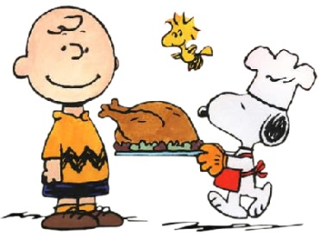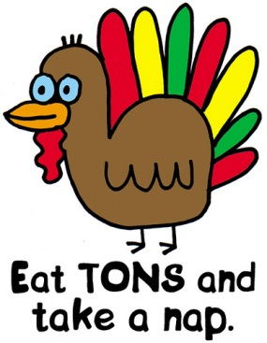

Bellwork #28
Motivational Monday!

Bellwork #29
Add or delete commas where necessary in the following sentences. If a sentence is correct, write “correct” after it.

Although the Beavers were expected to win they choked on Saturday night.

After my friends had gone inside I thought about what had just happened.

The night before I was leaving for OSU I was so excited.

I felt I had made the right choice but my sister disagreed with me.

As she stared at the wall, I knew something was wrong.

Bellwork #30
Free Write Friday!
1 paragraph today

Bellwork #31
Motivational Monday!
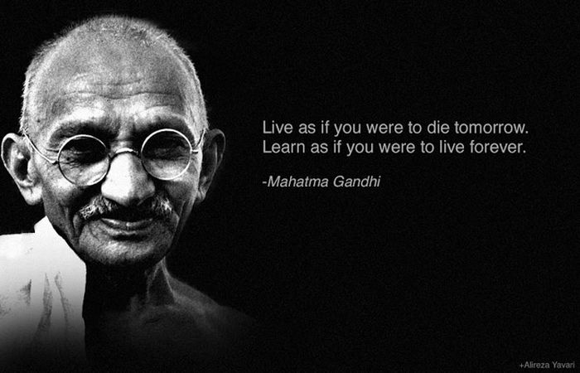

Bellwork #32
Complete a Delta Plus over the Vietnam Web-Quest, and answer the questions below:
- What did you learn about the research process?
- What aspect was most difficult for you?
- List an interesting fact you learned from the assignment about the War.
- List one thing you would like to know more about, about the Vietnam War or this time period.

Bellwork #33
Every family has different traditions surrounding the holidays. Please explain what Holiday, if any, you celebrate this time of year; and describe your family’s traditions.
1 paragraph min.

Bellwork #34
What topic did you and your partner select for your research project?
Draft 3 research questions that you can bring to your parter for discussion when we start working today.

Bellwork #35
List and Explain 3 Happies and 1 Crappy about your Winter Break!
**2 Parapraphs Minimum!!**

Bellwork #36
Motivational Monday!

Bellwork #37
Look at the sentences below. Tell whether the blue colored part of the sentence is the complete subject, complete predicate, or neither.
The horse ran in the field.
Subject | Predicate | Neither
The people in the house are having a party.
Subject | Predicate | Neither
Mom asked me to go to the store.
Subject | Predicate | Neither
The U. S. President spoke to the American people.
Subject | Predicate | Neither
Jose rode her bike to school.
Subject | Predicate | Neither

Bellwork #38
- Draw a line between the complete subject and the complete predicate.
- Circle the simple subject.
- Underline the simple predicate.
1. The microscopic dust mite was discovered less than three decades ago.
2. This eight-legged pest is related to the tick and the spider.
3. Do you ever wash your pillow in very hot water?
4. Someone in your household should probably do so as soon as possible.
5. The daily diet of the dust mite consists of tiny skin flakes on your pillow and sheets.

1. The microscopic dust mite was discovered less than three decades ago.
2. This eight-legged pest is related to the tick and the spider.
3. Do you ever wash your pillow in very hot water?
4. Someone in your household should probably do so as soon as possible.
5. The daily diet of the dust mite consists of tiny skin flakes on your pillow and sheets.

Bellwork #39
Subject Verb Agreement: select the correct verb for the sentence.
1. Annie and her brothers (is, are) at school.
2. Either my mother or my father (is, are) coming to the meeting.
3. The dog or the cats (is, are) outside.
4. Either my shoes or your coat (is, are) always on the floor.
5. George and Tamara (doesn't, don't) want to see that movie.
6. Benito (doesn't, don't) know the answer.
7. One of my sisters (is, are) going on a trip to France.
8. The man with all the birds (live, lives) on my street.
9. The movie, including all the previews, (take, takes) about two hours to watch.
10. The players, as well as the captain, (want, wants) to win.

Bellwork #40
Free Write Friday!
1 page min.

Bellwork #41
Motivational Monday (On a Tuesday)!
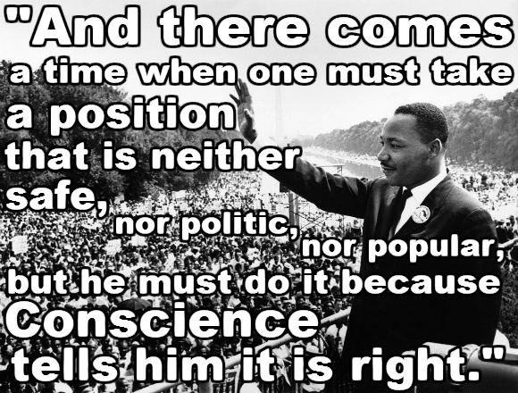

Bellwork # 42
Select the appropriate pronoun
1. Jane and Sarah said (she, they) were too tired to skate any longer.
2. Either Bill or John will bring a sample of (his, their) own work.
3. Jane and Jill called (her, their) friend.
4. Either Jane or her friends will present (her, their) project.
5. Neither Mary nor Susan said (she, they) would be there.
6. Every student wants to impress (his or her, their) professors.
7. Both John and Jim said (he, they) were not exercising regularly.
8. The jury was asked to return to (its, their) seats.
9. Please remind each student to bring (his or her, their) homework tomorrow.
10. Neither John nor Bob was willing to admit that (he, they) had cheated.

Bellwork #43
Select the appropriate pronoun

11. Each of the girls had (her, their) assignment completed.
12. Every worker in this office needs (his or her, their) own computer.
13. The committee finally made (its, their) decision public.
14. Nobody remembered to bring (his or her, their) photos.
15. Neither girl will wear (her, their) black pants.
16. Beth and Jane reported the problem to (her, their) supervisor.
17. Each teacher turned in (his or her, their) grades to the principal.
18. The choir presented (its, their) final performance.
19. Either the employees or Ms. Jones will make (their, her) presentation.
20. Both Suzi and Beth will try to see (her, their) parents over the weekend.

Bellwork #44

Free Write Friday!!
1 page min.

Bellwork #45
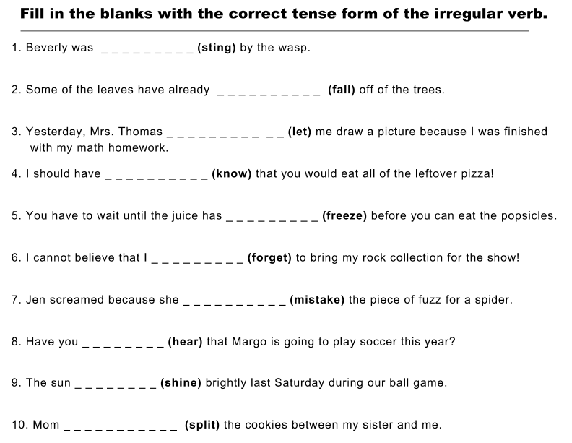

Bellwork #46
• In active voice sentences the subject does the action.
Example: Liz played the piano.
• In passive voice sentences the subject receives the action.
Example: The piano was played by Liz.
Directions: Decide whether the following sentences are written in the active or passive voice. Then write the doer of the action. If the doer is unknown,
write a question mark (?).
1) Thomas feeds his dog. active / passive ____________
2) The dog is fed by Thomas. active / passive ____________
3) The family went to the beach. active / passive ____________
4) The letter was written by Marshall. active / passive ____________
5) The game had been won by the blue team. active / passive ____________
6) The problem was solved. active / passive ____________
7)The stunt man risked his life. active / passive ____________
8) The fire was extinguished. active / passive ____________
9)The car was being cleaned by its owner. active / passive ____________
10) It gets cold here during the winter. active / passive ____________

Bellwork # 47
What are you going to write your Argumentative Essay about? Write a paragraph outlining your argument so far!

Bellwork #48
Free Write Friday!
1 paragraph

Bellwork #49
Write down your thesis statement and 3 reasons. Have a partner look at it and write down their feedback. 3 sentences min for feedback + thesis and reasons.

Bellwork #50
Motivational Monday!

Bellwork #51
List and explain anything you know about the Holocaust. 1 paragraph minimum.

Bellwork #52
List one new thing you learned about the Holocaust yesterday, and 1 thing you would still like to learn.

Bellwork #53
How do you think Anne feels about going into hiding? 1 paragragh min.

Bellwork #54
Free Write Friday!

Bellwork #55
Motivational Monday (On a Tuesday)

Bellwork #56
Select the correct verb.
1. Before I went to bed, I __________ (lie, lay, laid) my clothes out for tomorrow.
2. Every afternoon, we _________ (lie, lay, laid) on the bed for a nap.
3. When they’re cold, they _________ (lie, lay, laid) a blanket on their legs.
4. All of last week I __________ (lie, lay, laid) in bed feeling sick.
5. Our pet dogs like to __________ (lie, lay, laid) under the table.

Bellwork #57
Select the correct verb.
6. Yesterday, the boys __________ (lie, lay, laid) their backpacks outside.
7. While we meet, they __________ (lie, lay, laid) their purses on the couch.
8. Susanna and Maribel often __________ (lie, lay, laid) on the floor to make posters.
9. Last night we all __________ (lie, lay, laid) awake until midnight.
10. Yesterday, our teacher __________ (lie, lay, laid) on the ground, injured.

Bellwork #58
Free Write Friday
1 paragraph!

Bellwork #59
Motivational Monday!

Bellwork #60
Select the correct verb.
1. When I finally got back home, I (sit/sat/set) down in a chair.
2. He couldn’t remember where he (sit/sat/set) his wallet.
3. I promised my brother he could (sit/sat/set) beside me.
4. Before dinner each night I have to (sit/sat/set) the table.
5. We carried the heavy boxes inside and (sit/sat/set) them down.

Bellwork #61
Select the correct verb.
6. Grandmother Parkinson needs to (sit/sat/set) and rest.
7. When the dog wanted to come in, he (sit/sat/set) by the door.
8. Jessica came in from the rain and (sit/sat/set) her umbrella down.
9. Yesterday at the show, we were able to (sit/sat/set) in the first row!
10. When the mail arrives, I sort it and then (sit/sat/set) it on the desk.

Bellwork #62
What was the theme of Anne Frank? How do you know? Explain your thinking. 1 paragraph min.

Bellwork #63
Free Write Friday!
1 page min.
Bellwork Checks: 54-62

Bellwork #69
Motivational Monday
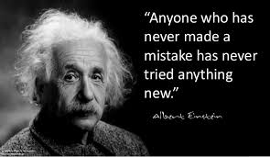
Bellwork #70
Underline the appropriate forms of the verbs in the parentheses to maintain consistent tenses in the following paragraph.
My grandmother was not at all the way my friends describe their grandmothers. They still (speak, spoke) of Grandma as a grey-haired old woman who (is, was) always forgetting things she should remember and remembering things no one else is very interested in. My grandmother (is, was) not at all like that. She (is, was) always very lucid. No matter what we (do, did) as children, Grandma always (wants, wanted) to hear about it. I will never (forget, forgot) my first date. I didn't even want my brothers and sisters to know about Ray. But Grandma! She (is, was) different. Even before I (tell, told) my mother, I (rush, rushed) over to grandma's and let her in on the secret. She just (smiles, smiled) and kept rocking and (tells, told) me to be sure to bring Ray over to meet her sometime. That night, on the way to our first dance together, Ray and I (stop, stopped) in for a minute to see Grandma. She (is, was) someone we always wanted to share our secrets with.

My grandmother was not at all the way my friends describe their grandmothers. They still (speak, spoke) of Grandma as a grey-haired old woman who (is, was) always forgetting things she should remember and remembering things no one else is very interested in. My grandmother (is, was) not at all like that. She (is, was) always very lucid. No matter what we (do, did) as children, Grandma always (wants, wanted) to hear about it. I will never (forget, forgot) my first date. I didn't even want my brothers and sisters to know about Ray. But Grandma! She (is, was) different. Even before I (tell, told) my mother, I (rush, rushed) over to grandma's and let her in on the secret. She just (smiles, smiled) and kept rocking and (tells, told) me to be sure to bring Ray over to meet her sometime. That night, on the way to our first dance together, Ray and I (stop, stopped) in for a minute to see Grandma. She (is, was) someone we always wanted to share our secrets with.

Bellwork #71
Motivational Monday!
Get out your Chromebook and email me your JPEG of your infographic if you haven’t already done so!!

Bellwork #72
Directions: Use quotation marks, capital letters, and any other punctuation necessary to rewrite the following sentences correctly. Write “Correct” if the sentence does not need any additional punctuation.
1) Are we there yet she asked.
___________________________________________________________________
2) I am tired the boy said and then drifted off to sleep.
___________________________________________________________________
3) We really should be going now she said.
___________________________________________________________________

Bellwork #73
Directions: Use quotation marks, capital letters, and any other punctuation necessary to rewrite the following sentences correctly. Write “Correct” if the sentence does not need any additional punctuation.
1) Excuse me he said do you have the time?
___________________________________________________________________
2) Mommy can I have an apple he asked.
___________________________________________________________________
3) The mother said that the obnoxious child simply had a lot of energy.
___________________________________________________________________

Bellwork #74
Directions: Insert any semicolons or commas needed in the following sentences.
1. He slept through his alarm luckily his first class was cancelled.
2. Tripping over the dog I dropped my cup.
3. We practiced every day after school and all Saturday however we lost the game.

Bellwork # 75
Free Write Friday!!
1 page min.

No Bellwork today – Get out your Chromebook and login to iReady to be sure your connection is working. DO NOT START YET!!

Bellwork # 76
Choose are or our to complete each sentence.
1. We have to clean _______________________ rooms this afternoon.
2. The birds _______________________ blue.
3. We _______________________ late for school.
4. _______________________ teacher read a story to us.
5. Her friends _______________________ playing in the park.
6. It’s _______________________ turn to play on the swings.
7. Where _______________________ you?
8. _______________________ bus goes by the library.
9. May we open _______________________ presents?
10. They _______________________ eating their lunch with us.

Bellwork # 77
Each of the following sentences uses one or more of these words: there, their or they’re; rewrite the correct word on the line.

1. The library book is over their. __________________
2. Cats use their tongues to groom themselves. __________________
3. Did they forget there lunches at home? __________________
4. The students handed in they’re best work. __________________
5. This is a day there not going to forget. __________________
6. It’s too far, so we don’t go their anymore. __________________
7. James and Maria hung their coats in there lockers. __________________
8. There are always enough snacks for everyone. __________________
9. The teacher hung they’re art on the bulletin board. __________________
10. You’ll find the glue and scissors in their. __________________

Bellwork #78
List and explain 2 happies and a crappy from your Spring Break. 1 paragraph min.

Bellwork #79
Answer the following multiple choice questions.
- The atmosphere or feeling in a literary work is called the:  - conflict  - protagonist  - mood  - text features  - Pictures, side bars, bold print, graphs, charts, and captions are examples of:  - foreshadowing  - text features  - personification  - alliteration  - A struggle or problem in the story for the main character is the:  - protagonist  - metaphor  - flashback  - conflict | - A piece of writing that can be found in newspapers and magazines and its purpose is to persuade is:  - editorial  - feature article  - myth  - short story  - A piece of writing that can be found in newspapers and magazines and its purpose is strictly to inform is:  - editorial  - feature article  - myth  - short story

Bellwork #80
Answer the following multiple choice questions.
- An ancient Greek story that explains natural occurrences/happenings in the world is:  - editorial  - feature article  - myth  - short story  - The main character is the:  - dialect  - meter  - plot  - protagonist  - A prediction or hints of what will happen is called:  - foreshadowing  - personification  - alliteration  - genre | - “Life is like a box of chocolates” is an example of:  - metaphor  - simile  - meter  - onomatopoeia  - “My cat is a log” is an example of:  - metaphor  - simile  - meter  - onomatopoeia

Bellwork #81
Answer the following multiple choice questions.
- Giving non-human objects human characteristics is called:  - foreshadowing  - personification  - dialect  - alliteration  - When the author takes the reader back in time to a memory, he/she is using the technique called:  - foreshadowing  - alliteration  - flashback  - figurative language  - “Bob built a brilliant boat” is an example of:  - foreshadowing  - simile  - metaphor  - alliteration | - A form of language spoken by people in a particular region is called:  - dialect  - dialogue  - fable  - meter  - A brief story/poem, usually with animal characters, that teaches a lesson/moral is called:  - folk tale  - fable  - haiku  - resolution

Bellwork #82 TAKE YOUR AR TEST!!!!
Answer the following multiple choice questions.
- A story composed orally and passed down by word of mouth is called a(n):  - folk tale  - fable  - haiku  - resolution  - A type of literature is called:  - meter  - setting  - genre  - plot  - The rhythmical pattern of a poem is called:  - figurative language  - dialogue  - meter  - onomatopoeia | - A 3-line Japanese poem with 17 syllables is called:  - folk tale  - fable  - haiku  - myth  - BAM is an example of:  - onomatopoeia  - figurative language  - genre  - plot

Bellwork #83
Answer the following multiple choice questions.
- When characters speak, it is called:  - figurative language  - dialogue  - dialect  - mood  - “That was so good, I could smack my Mammie!” is an example of:  - personification  - alliteration  - figurative language  - simile  - When, where, and the time a story takes place is called the:  - plot  - setting  - resolution  - conflict | - When the climax or conflict is solved it is called the:  - plot  - setting  - resolution  - conflict  - The sequence of events in a story is the:  - setting  - conflict  - resolution  - plot

Bellwork #84
Directions: Read the following examples of irony. Determine which of the three types of irony are being used and then explain your answer.
Dramatic irony – This occurs when the reader or audience understands more about the events of a story than a character.
Situational irony – This occurs when what actually happens is the opposite of what is expected or appropriate.
Verbal irony – A character says one thing but really means the opposite.
- A mean old man ate a large meal at a restaurant. The waitress tried to provide him with excellent service, but every time she brought him a dish, he complained. First he thought that the soup was too cold when it was hot. Then he said that his steak was dry and chewy, when it was moist and succulent. Then he complained that one of her blonde hairs was in his mashed potatoes, but the hair was actually grey like his own. She remained patient and continued to try to help him until the end of the meal, when he left her a quarter for a tip. She replied on his way out, “Thank you for the generous tip, Mister.”
Which type of irony is used? ____________________________________________________________
Explain your answer in complete sentences:
- Tom has always liked Lucy, but Lucy has always thought Tom was annoying and unattractive. One day, Lucy comes home to find an eviction notice on her door. Apparently, her roommate had been spending the rent money that Lucy was giving her on other things. Lucy only has 24 hours to get all her stuff over to her mom’s house, and Lucy doesn’t even have a car. But Tom has a truck. So Lucy calls up Tom and asks him how he’s doing. She tells him that she’s always thought he was funny, and that they should hang out sometime. Tom thinks that Lucy has finally come around is beginning to like her. He also thinks that his jokes are funny because she is laughing after everything that he says.
Which type of irony is used? ____________________________________________________________
Explain your answer in complete sentences:

Get your Chromebook out and begin working.
**Bellwork Checks today!!! 75-84
****Have your notebooks out and ready for me to check!

