"Ultimate African experience" costs famous lion his life
By Associated Press, adapted by Newsela staff
08.04.15
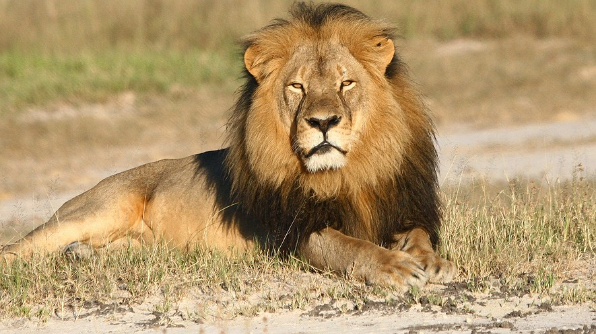
In this undated photo provided by the Wildlife Conservation Research Unit, Cecil the lion rests in Hwange National Park in Hwange, Zimbabwe. Photo: Andy Loveridge/Wildlife Conservation Research Unit via AP
JOHANNESBURG — For wealthy foreign visitors, it is the ultimate African experience: the thrill of hunting a lion, the mighty king of the jungle. Lions, though, are one of the "Big Five" animals whose habitats are under increasing pressure from human encroachment.
An American dentist's killing of a celebrity lion in Zimbabwe has triggered global revulsion. The incident has highlighted what critics say is an industry of trophy hunting that threatens vulnerable species across sub-Saharan Africa.

Hunting Not Banned Everywhere
Hunting is banned in Kenya and Botswana, which depend heavily on income from tourists who flock to see wildlife. Many more countries, including South Africa, Namibia and Tanzania, allow it. They argue that it benefits communities and funnels high-priced fees from hunters back into conservation. Opponents, however, warn that regulations are often poorly enforced or overlooked by unscrupulous operators.
Such suspicions are swirling in Zimbabwe, where a professional hunter, Theo Bronkhorst, has been charged with failing to "prevent an unlawful hunt." Bronkhorst was working for Minnesota resident Walter James Palmer, who killed Cecil, a well-known lion with a distinctive black mane, in early July. Conservationists say a dead animal was tied to a car to draw the lion out of a national park. Palmer first wounded Cecil with a bow before fatally shooting him with a gun after 40 hours of tracking.
Palmer, who said he relied on his professional guides to ensure a legal hunt, has been criticized globally on social media and talk shows. He has closed his dental practice for now.

"Blood Lions" Exposes Killings
"Cecil is not the first lion that has been lured," said Ian Michler, a South African conservationist. "It goes on all the time. Unethical hunting is rife across the continent."
Earlier this year Michler released a documentary film on the trophy hunting of lions, called "Blood Lions." He said nearly 1,000 lions that are bred in captivity in South Africa are fatally shot every year by trophy seekers for an average of about $20,000, and sometimes up to $50,000. The kills take place in conditions that can hardly be described as sporting, he said. There is also an increasing phenomenon of lion owners charging tourists to pet and cuddle cubs earmarked for trophy kills when they get older, he added.
South Africa maintains that its legal hunting industry adheres to international agreements. It says the industry actually contributes to the welfare of species, including lion, elephant and rhino.

Trophy Hunting Is Big Business
Hunting "is a source of much needed foreign exchange, job creation, community development and social upliftment," South Africa's Environment Minister Edna Molewa said.
Molewa welcomed a recent decision by South African Airways, the national airline, which announced that it will lift an embargo on the transport of legally obtained hunting trophies of lion, elephant, rhino and tiger.
Molewa said the industry in South Africa is valued at about $490 million annually. Some conservationists, however, believe the figure is inflated to support the argument that hunting is an economic boon. In a 2013 report, a group called Economists at Large cited estimates that trophy hunting generates $200 million in African communities. It added that the figure should be used "with caution" and that the amount in question is a relatively insignificant part of total tourism revenue.

Cecil's Movements Were Tracked
Lions are designated as vulnerable on an international "red list" of species facing threats. By one estimate, fewer than 20,000 lions exist in the wild, a drop of about 40 percent in the past two decades. Another estimate puts the number closer to 30,000. The International Union for Conservation of Nature has taken note of successful lion conservation in southern Africa, but said West African lions are critically endangered and that rapid population declines were also recorded in East Africa.
Cecil, the Zimbabwean lion that was killed, was wearing a satellite collar. The collar had been installed by the University of Oxford's Wildlife Conservation Research Unit to keep track of his movements.
"Our goal is to understand the threats that lions face, and to use cutting-edge science to develop solutions to those threats," Director David Macdonald said. He said the unit has tracked the movements of more than 100 lions by satellite.
Prince Mupazviriho, of Zimbabwe's ministry of the environment, water and climate, said the hunting of a collared lion was an isolated incident. Controlled, legal hunting, he said, is a useful way to keep animal populations in a healthy balance.
"Short of going on a culling exercise where you are just shooting animals willy-nilly in order to reduce numbers, there is need to have a scientific way of doing it," he said.

"King Of Beasts"
This year, Zambia announced the lifting of a 2-year-old ban on hunting lions and other big cats.
On its website, a group called Central African Wildlife Adventures offers hunts in the Central African Republic. The website describes an almost mystical experience in which the hunter and the hunted lion are equals.
"The last and final contact is usually done at close range," the website claims, "with the lion appearing from nowhere in the green foliage. Without a warning or a sound, the King of Beasts is suddenly there and the time has come for two of the most powerful predators on earth to meet."

Copyright 2015 The Associated Press. All rights reserved. AP material may not be published, broadcast, rewritten or redistributed.

Which detail from the article is MOST relevant to the main idea?
- Palmer wounded Cecil with a bow and arrow, then shot him.
- Michler made a film about hunting lions in captivity.
- Tourists can pay to pet and cuddle baby lions.
- A website offers hunts in the Central African Republic.
Which sentence or paragraph from the section “Cecil's Movements Were Tracked" does NOT support its central idea?
- By one estimate, fewer than 20,000 lions exist in the wild, a drop of about 40 percent in the past two decades.
- The International Union for Conservation of Nature has taken note of successful lion conservation in southern Africa, but said West African lions are critically endangered and that rapid population declines were also recorded in East Africa.
- The collar had been installed by the University of Oxford's Wildlife Conservation Research Unit to keep track of his movements.
- "Our goal is to understand the threats that lions face, and to use cutting-edge science to develop solutions to those threats," Director David Macdonald said.
What is one reason why Zimbabwe allows lion hunting?
- Social media users and talk shows have pressured them to support hunting.
- Regulations about hunting are not always well enforced.
- Hunting can help keep animal populations balanced.
- Their tourism industry relies completely on hunting.
According to the article, what does Prince Mupazviriho believe about lion hunting?
- that a protected lion could be lured to its death
- that the effects of lion hunting in Zimbabwe are unacceptable
- that legal hunting and poaching are bad for the lion population
- that legal hunting is a useful way to control the lion population

WRITE:
- Pick a detail from this article. Explain how it helps you understand the bigger ideas in the article. 1 paragraph min.
- What is the main idea of this article? How does it relate to the 2 articles we read in Scholastic Scope?
- Do you feel that the author of this articles main idea conflicts with or agrees with the 2 Scholastic Scope articles?

