Step 1:
Click the blue box that says File in the top left hand corner of the screen.
Your Screen should look like this after you have clicked it:
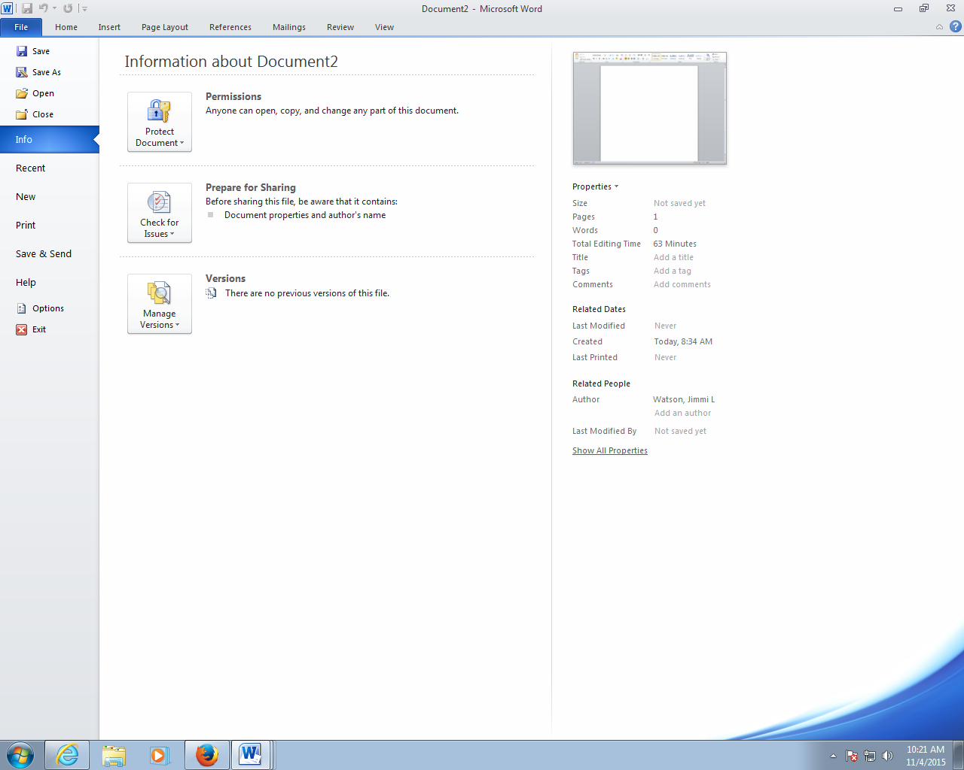
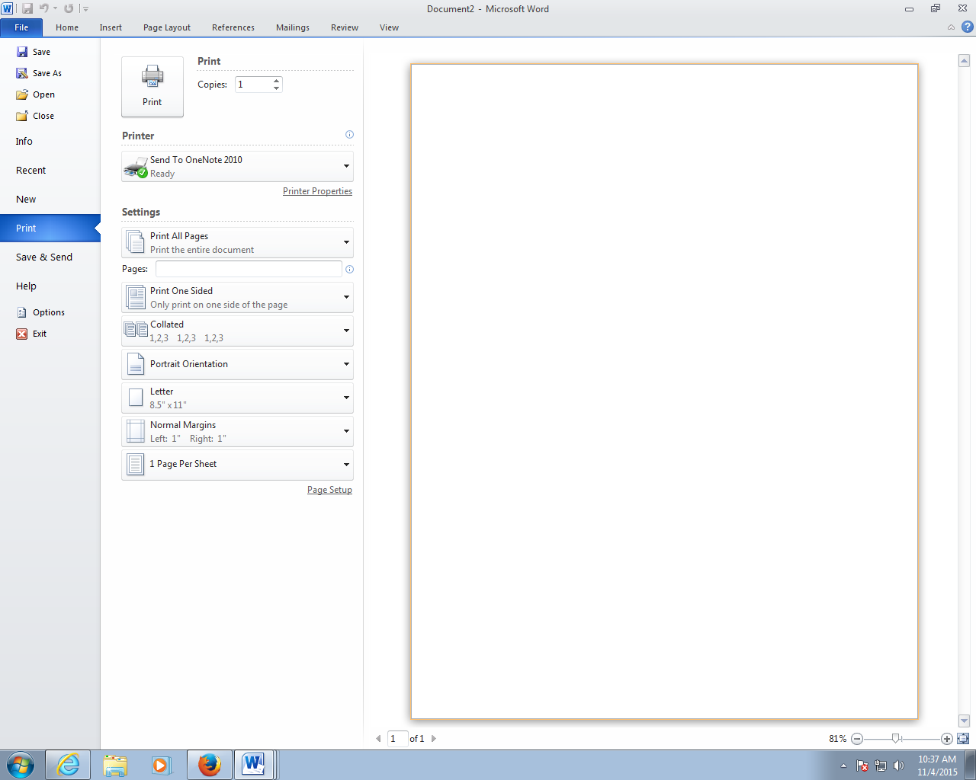
Step 2:
Click Print on the left hand menu.
Your screen will then look like this:

Step 3:
Under the printer option, select the correct printer for your lab location.

Then click Print in the big square:

