Step 1:
Click the blue box that says File in the top left hand corner of the screen.
Your Screen should look like this after you have clicked it:
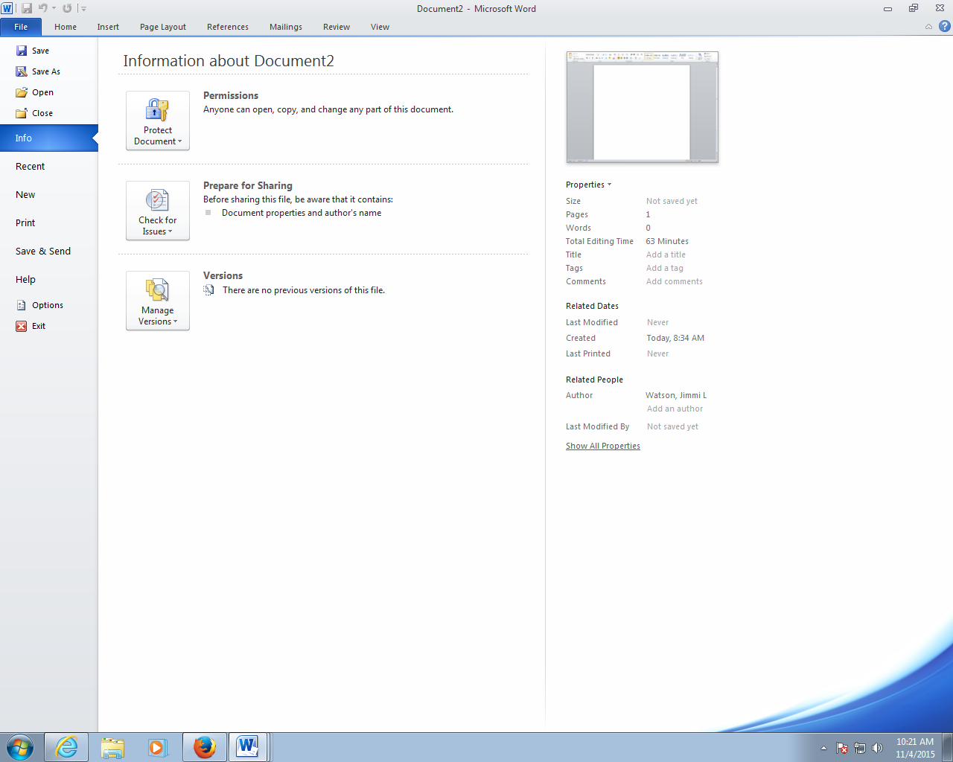
Step 2:
Click Save As on the left hand menu.

A dialogue box will appear
on your screen:

Step 3:

In the left hand box,
scroll down until you find Computer,
double click on it.

Step 4:
Find the drive that begins with your graduation year, followed by your last name, and double click on it.
It will be located under Network Location.

Step 5:
Backspace whatever is in the File name box out, and replace it with your last name followed by the assignment name.
For example: Watson Short Story
Then click Save.

