MLA Format Instructions for Google Docs
Open Google Docs
Select a Blank Document

Change Font to Times New Roman

Change Font Size to 12

Click Insert: Page Number
Select the option that puts it at the top right hand side
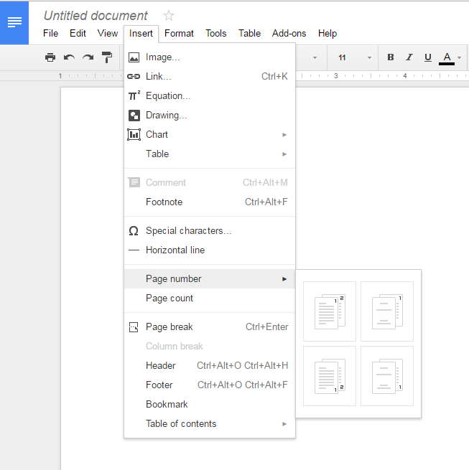
Type your last name next to the number

Double click underneath the line
Click Format; Line Spacing; Double
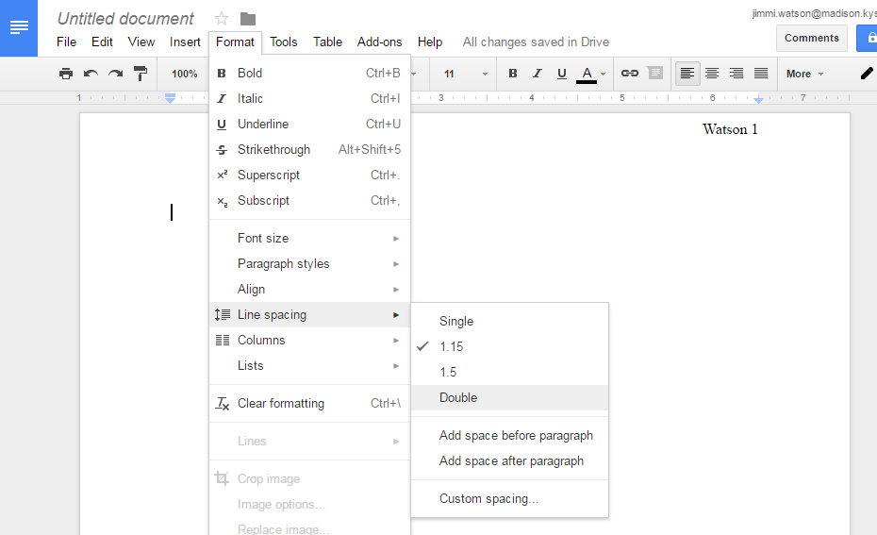
At the top of your page write the following:
Your Name
Mrs. Watson
English 8
27 October 2016

Center your cursor by clicking on the line spacing. Type your title.

Your finished product should look like this:

