Text Feature and Structure Analysis
- List the main idea of each article.
- What is the each author’s purpose for writing each of the articles? (Persuasive, Informational, or Entertaining?)
- How is each article organized? (Chapters, Paragraphs, Sections, etc.)
- What features do you see being used in each article?
- How does each of these features contribute to the overall understanding of each article?
- List the structure of each text.
- Write a one paragraph summary of each article.
- Write 1 paragraph about how the texts features support the texts structure and how the structure helps develop understanding of each text.

LeBron vs. Jordan, Duncan vs. Kobe: Matchups you feel but can't see
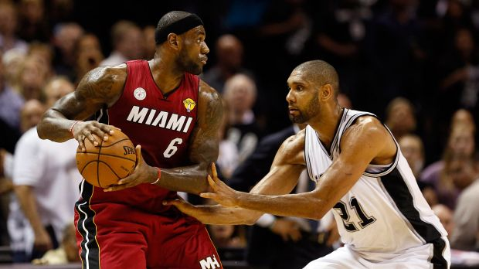
Soobum Im / USA TODAY Sports
If LeBron James and Tim Duncan meet again in The Finals, they'll be both playing against each other and for their place in history.
Something incredible is happening in the shadow of these NBA playoffs: Two of the greatest players of all time are making their assault on two of the most impressive legacies the game has ever offered us.
The first is LeBron James’ continuing quest to topple Michael Jordan as the greatest basketball player of all time, a goal LeBron has become candid about, including in a sitdown interview with me before the season started.
The other is Tim Duncan’s much less talked about but increasingly possible takedown of Kobe Bryant’s standing as his era’s best player.
Let’s start with LeBron. He is without a doubt the most talented basketball player on earth, and his attempt to Be More Like Mike than Mike seems both possible and still as daunting as it was when Sports Illustrated first threw him on its cover with the words, “The Chosen One.”
Jordan won six titles. All six times he was the MVP of The Finals. So Jordan never failed to be the most important player in a series on which a championship rested, as LeBron has twice; he never choked, as LeBron so clearly did in his first Finals with the Miami Heat.
But Jordan didn’t have LeBron’s almost supernatural skills. And while LeBron did fall under the weight of all the ugliness he created that first year in Miami, there’s a good chance that experience shaped him – forged him, really – into something capable of attacking the highest mountain in all of basketball: the one where the only face chiseled on the side is that of Air Jordan.
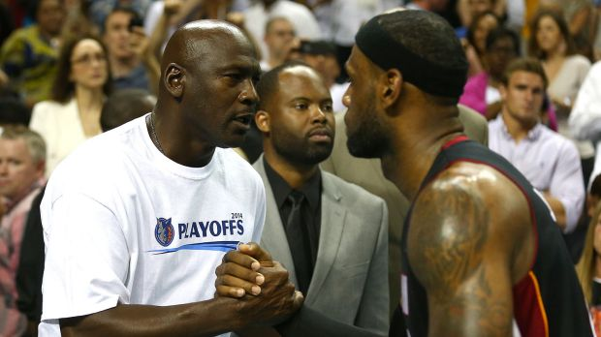
Streeter Lecka-Getty Images North America
James doesn't yet have Michael Jordan's six rings, but he does have plenty of years ahead of him to catch up.
LeBron has a long, long ways to go. But notching his first three-peat would be a giant step in that direction.
Duncan’s journey toward his own incredible place in the history of the game is clearer because we can grasp more completely (as we can with Kobe) the fullness of his career. Both men have, most likely, only a few years left. The second half of LeBron’s career is guesswork. The second halves of Kobe and Duncan’s careers have mostly happened.
Win one more title, and Duncan matches Kobe in rings, but passes him as an all-time great.
He and Kobe are both somewhere between the top five to 12 players of all time, and their careers are linked both in what they share and what they do not.
Kobe arrived in 1996 but out of high school. Duncan arrived a year later but after four years of college. Kobe was flashy, a guard, a shooter, all Hollywood and buzz and, yes, that controversy, and he won and lost on one of the game’s brightest stages.
Duncan was the quiet big man, playing in the sleepy NBA backwaters of San Antonio. Both men will play their entire careers with one team. Both men are among the greatest ever – short of Jordan, short of where LeBron hopes to tread, but very close to each other.
If Duncan matches Kobe Bryant's five titles, he'll likely surpass his contemporary's legacy.
Kobe has five titles, Duncan four. But slip on another ring and their resumes shift. Kobe has always been a master of the media, but if Duncan gets to five he becomes the master of the court. Duncan has two MVPs, Kobe one. Duncan has three Finals MVPs, Kobe two.
It is the last two years that have put Duncan so clearly within grasp of Kobe’s legacy. While Kobe spent his time “leading” one of the most disappointing teams in NBA history and then missing all but six games this season with injuries, Duncan enjoyed a late-career resurgence that included an NBA Finals appearance last year. And here he is again, chasing another title while we wonder whether Kobe will even make the playoffs again.
You can argue for Kobe, of course, as so many Lakers fans surely will. And you can feign indignation that one would put the quiet, plodding, “boring” Duncan ahead of a guy who nicknamed himself Black Mamba and too often decided to strike at his own teammates or coaches. But there is no insult in calling one man greater than another when you put both squarely among the 12 greatest of all time.
They are both legends, and what made Kobe impossible to play with to some made him impossible to beat to so many others. There is no unwinding each man from the player and the greatness they have shown us.
Still, facts are facts. And Phil Jackson, in his autobiography, did call Kobe “uncoachable.” Duncan, meanwhile, quietly signed for less money and built a dynasty in San Antonio, far from the spotlight and the credit and the praise.
Whereas Kobe couldn’t play with Shaq, couldn’t make it work with Dwight, and took a giant end-of-his-career contract that makes it much harder for the Lakers to keep winning, Duncan ceded the stage to Tony Parker. And so the Spurs kept winning, and the Lakers did not.
That is what is at stake in this postseason: not just a championship but Kobe’s place in NBA history and, perhaps eventually, Jordan’s.
The idea of LeBron eventually becoming the Greatest of All Time or of Duncan overtaking Kobe will be unwelcome for many of you. I get it. That reaction makes sense. We crave to see greatness – all-time greatness, in all things about our time and place – and then we cling fiercely to nostalgia. It was true of our fathers, and their fathers, too. It’s the most human of reactions – to see in the history around us what we’d like to see in ourselves: uniqueness, beauty, meaning.
I’m guilty of it, too. When we glimpse something that transcends us or – as sports and art do, at their best – underscores something about us and our time here, we don’t just love it. We cling to it. We defend it. We protect it – particularly against something that might surpass the thing we so cherish. Something like LeBron, or like Duncan.
With the Heat’s 102-90 win over the Indiana Pacers on Monday night putting them up 3-1 in the Eastern Conference finals and the Spurs able to take the same lead out West against the Thunder if they win Tuesday night, Duncan and LeBron again seem on a collision course for each other.
So this seems a particularly good week to contemplate LeBron and Duncan’s all-time value.
Duncan’s quest seems open-and-shut to me. Win another ring, and he passes Kobe. Fail, and he doesn’t.
LeBron has further to go, and it’s that journey I can’t wait to take in. Personally, I don’t think he gets there. Not past Jordan. Not quite.
But I could be wrong. Which is why these NBA Finals and the postseason leading up to them are about more than one ring, one game, one thrilling moment in time.
LeBron James and Tim Duncan are chasing history, and I crave the idea of sitting back and watching one all-time great go after another.
Bill Reiter

How to Apply Eyeliner
Press flat end of eyeliner brush lightly along the base of lash line, using long sweeping strokes

.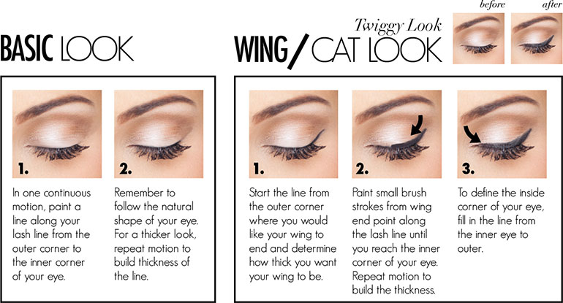

Look up! From your cellphone, that
is
In this July 10, 2012, photo, pedestrians cross K Street and Connecticut Avenue NW near the Farragut
North Metro entrance in downtown Washington, D.C. Photo: AP Photo/Pablo Martinez Monsivais
WASHINGTON — People distracted by cellphones are walking in front of cars, into trees and street signs. They are falling off curbs and bridges. They’re walking into wet cement.
They have suffered cuts and bruises, and head injuries — some have even been killed.
Many cities and states are promoting walkable neighborhoods, in part to attract more young people. At the same time, some are also giving tickets to distracted walkers and lowering speed limits to make streets safer for pedestrians.
Pedestrian injuries caused by cellphone use are up 35 percent since 2010,
according to federal emergency room data reviewed by Stateline.
Danger Zones
Every year, thousands of pedestrians are injured as they walk in cities and some
researchers blame at least 10 percent of those injuries on distraction by a
mobile device, such as a phone or portable music player.
By Stateline.org, adapted by Newsela staff on 12.17.14
Word Count 802
To reduce the number of injuries and deaths associated with distracted walking,
Utah and New Jersey have experimented with fines for texting in dangerous
walking situations. New York state has lowered speed limits in New York City, in
part to make traffic less dangerous for distracted walkers.
“We have to design streets for the way people actually behave, and behavior is
changing,” said Noah Budnick of NYC-based Transportation Alternatives. “If
you’re looking at a phone when you’re walking around, that shouldn’t mean
death. So we have to design forgiving streets.”
Slowing The Cars
New York City has new speed limits — 20 miles per hour (mph) in Central Park
and 25 mph in the rest of the city unless otherwise posted. The city has also
been blocking off more streets to make safer pedestrian plazas.
U.S. Secretary of Transportation Anthony Foxx has given $1.6 million in grants to
Louisville, New York City and Philadelphia for walker-safety programs.
“We’ve got to encourage people to have an awareness that this problem is a
real problem,” Foxx said last year.
In 2012, 78,000 pedestrians were injured — the highest number since 2001 —
according to the National Highway Traffic Administration.
Also in 2012, 4,700 walkers were killed, a number that has been increasing
since 2009, after falling for several years before that.
Stay In Your E-Lane!
Some areas are focusing on stopping people who are not paying attention while
walking. In Utah, distracted walkers can face a $50 fine. In New Jersey, police
used jaywalking laws to crack down on people using phones while walking into
traffic.
Philadelphia had a different strategy: They made a joke of it. On April Fools’ Day
2012 the city painted “e-lanes” on sidewalks, reserved for people staring at their
phones.
“We know that many, many people are using the sidewalks, looking at their
iPhones, BlackBerrys, other electronic devices and they’re quite distracted by
those devices, bumping into people,” Mayor Michael Nutter said in a video, as a
distracted walker bumped into him.
But many pedestrians interviewed by the city seemed to like the idea and take it
seriously.
“As a (cellphone) user, it’ll keep most of those bozos out of my way,” one
onlooker said.
“I’m a severe texter and walker, so I don’t know if I can quit on my own,” another
said.
Minnesota, Utah, North Carolina, South Carolina and Washington state have also
started pedestrian safety programs to reduce traffic deaths.
San Francisco is pledging $50 million for its Walk First program and will
scrutinize “high injury corridors” to determine why they are so dangerous.
The plan also proposes improvements such as raised crosswalks and traffic
islands for pedestrians.
Distracted Drivers And Walkers Collide
Distracted driving is also causing more pedestrian deaths, researchers say,
because a driver and a walker each staring at their cellphone can be a
dangerous combination.
Half of pedestrians admit to talking on the phone while walking across the
street. One out of 4 say they text or email while crossing the street, even though
most realize it’s dangerous, according to a survey last year by Liberty Mutual
Insurance.
“So much attention has been paid, and rightly so, to distracted driving, that we
have ignored the fact that distracted walking and crossing can be just as risky,”
said David Melton, a driving safety expert with Liberty Mutual.
While working as an emergency room doctor, University of Buffalo researcher
Dr. Dietrich Jehle studied pedestrian injuries. He estimates that 1 in 10
pedestrian injuries is now related to distracted walking, and that it causes more
accidents than distracted driving.
Texting is the most dangerous thing to do while walking, even more dangerous
than listening to music or talking on the phone, he found.
A 2011 study found that texting while walking seriously impeded navigation. In
simulations, walkers had a 61 percent error rate while distracted.
“While talking on the phone is a distraction, texting is much more dangerous
because you can’t see the path in front of you,” Jehle said.

Nike Release Dates 2015: KD 7 ‘Longhorn State’, Kyrie 1 ‘Deceptive Red’ – Price, Where to Buy, Photos

By Paul John Rivera (staff@latinpost.com) First Posted: Jan 04, 2015 01:29 PM EST
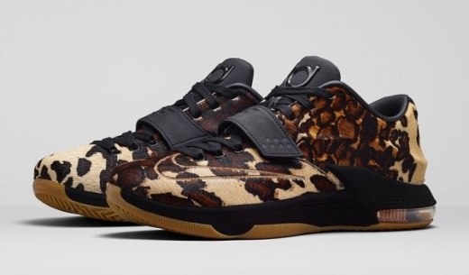
The KD 7 "Longhorn State" will come out on on Friday, January 9, for $200 per pair worldwide. (Photo : Twitter, Nikestore)

Nike is aiming to start this year with a blast as it is set to release new colorways of two popular signature shoes that have been getting a lot of attention on the sneaker market recently.
In the second week of 2015, new colorways of the latest signature sneakers of Oklahoma City Thunder forward Kevin Durant and Cleveland Cavaliers point guard Kyrie Irving are set to hit the market.
The KD 7, Durant's seventh signature shoe with the company, will come out in what is dubbed as the "Longhorn State" edition, which is officially listed as the Black/Sail colorway of the shoe. This excellent-looking shoe will hit the market on Friday at 10 a.m. EST on Nike.com and select stores worldwide.
The KD 7 "Longhorn State" was made to pay tribute to Austin, Texas, where the reigning NBA Most Valuable Player spent his collegiate career. According to Nike, the animal print on the upper part was inspired by Texas Longhorns' rich heritage combined with Durant's record-setting career at the university.
"The upper features all-over pony hair, mirroring the steer's spotted hide. Black accents are present on a suede flocked midsole, signature strap and tongue where his initials are displayed," according to Nike. "Cementing Durant's one-year legacy before turning pro, a branded Swoosh on the toe and heel marks two of his greatest achievements–leading all freshmen in scoring and becoming the first freshman to win the most prestigious player award."
Fans can get their own pair of the new KD 7 "Longhorn State" for $200 per pair. Official photos of Durant's latest signature shoe are available here.
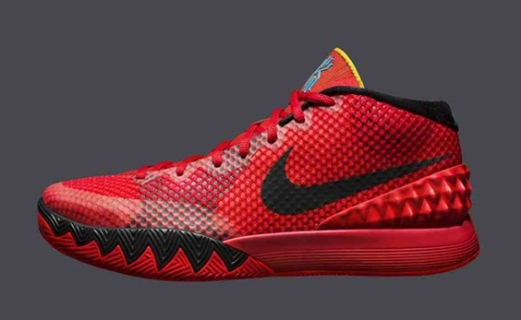
(Photo : Twitter, Nikestore) Kyrie 1 "Deceptive Red"

Aside from the new KD 7, Nike will also release another colorway of Kyrie 1, Irving's first Nike signature shoe. It will hit shelves in "Deceptive Red" edition, which is officially listed as the Bright Crimson/Black-University Red-Blue Lagoon colorway of the signature sneaker, on Saturday.
Inspired by Irving's quickness and deadly first step on the hardcourt, the Kyrie 1 "Deceptive Red" features a red-based upper part combined with black and blue lagoon accents, and finished off with a university red sole.
Aside from its impressive look, the new Kyrie 1 boasts performance-based features that were integrated in the shoe to match Irving's unique skill set on the hardcourt.
"When designer Leo Chang and team began the design process of the Kyrie 1, the goal was to build a shoe to match Irving's tremendous speed and quickness," Nike wrote. "The Kyrie 1 needed to be light, bold and responsive with the best traction Nike Basketball could develop for Irving's prolific first step."
The Kyrie 1 "Deceptive Red" will be available for $110 on Nike.com and select Nike retailers worldwide. More detailed images of this signature shoe are available on this link.

Rap listeners prone to alcohol, drugs, violence
Study raises questions about alcohol industry marketing through hip hop
BERKELE Y, CA - Young people who listen to rap and hip hop music are more likely to have problems with alcohol, drugs and violence than listeners of other types of music, a new study shows. The link to these problems raises serious questions about the alcohol industry's use of rap and hip hop to market products, the study author said.
A survey of more than 1,000 community college students found that rap music was consistently associated with alcohol use, potential alcohol use disorder, illicit drug use and aggressive behavior. Alcohol and illicit drug use were also associated with listening to techno and reggae. The results were not affected by the respondents' gender or ethnicity.
"People should be concerned about rap and hip hop being used to market alcoholic beverages, given the alcohol, drug and aggression problems among listeners," said lead author Meng-Jinn Chen, Ph.D., a research scientist at PIRE Prevention Research Center. "That's particularly true considering the popularity of rap and hip hop among young people."
Rap and hip hop music and artists have been used in commercials and advertisements for malt liquor and other alcohol products, while the urban contemporary music radio format, which features rap and hip hop, is regularly used for alcohol advertising.
The study, published today in the May issue of the Journal of Studies on Alcohol, surveyed over 1,000 students aged 15 to 25. Students were asked about their music listening habits, alcohol use, illicit drug use and aggressive behaviors - such as getting into fights and attacking or threatening others. Researchers emphasize that the survey results cannot determine whether listening to certain music genres leads to alcohol or illicit drug use or aggressive behavior. Young people with tendencies to use alcohol or illicit drugs or to be aggressive may be drawn to particular music styles.
"While we don't fully understand the relationship between music preferences and behavioral outcomes, our study shows that young people may be influenced by frequent exposure to music lyrics that make positive references to substance use and violence," Meng-Jinn said.
Recent studies of popular music by other researchers reveal that nearly half of rap/hip and hop songs mentioned alcohol as compared to around 10 percent or less of other popular music genres. Nearly two-thirds of rap songs mentioned illicit drugs as compared with one-tenth of songs from other genres. Rap and rock music videos depict violence twice as often as other music genres.
The PIRE study, entitled "Music, Substance Use and Aggression," also found that young people who listen to reggae and techno used more alcohol and illicit drugs than listeners of other music, with the exception of rap. Rap topped all other genres in association to alcohol and drug use and aggression.
The study was funded by the National Institute on Alcohol Abuse and Alcoholism (NIAAA). The PIRE Prevention Research Center is sponsored by NIAAA. PIRE, or Pacific Institute for Research and Evaluation, is a national nonprofit public health research institute with centers in seven cities and funded largely by federal grants and contracts.
Research and surveys show that girls are being targeted by the makers of “alcopops,” fruity, sweetened beverages that taste like soda pop but contain alcohol levels that are the same or higher than beer. These drinks pose heightened risks during Spring Break, when many high school and college students travel to exotic locales for extreme partying.

