Young Goodman Brown Gravestone Activity
Directions: Read over the following questions and with these in mind view the gravestones and read the epitaphs below. When you are done, answer the questions fully.

1. What do you notice about the use of language and punctuation on early New England gravestones?

2. What social and/or religious values and beliefs are stated or implied in the epitaphs?

3. What insights do you gain into daily life in early New England?
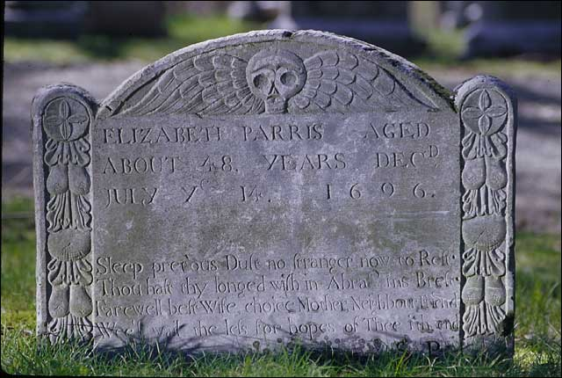
Gravestone of Elizabeth Parris, 1696, Wadsworth Cemetery, Danvers, Massachusetts.
Slate gravestone of Elizabeth Parris, wife of Rev. Samuel Parris of Salem Village. It was in her house, the old parsonage, that Tituba the Barbados slave told stories of the occult to impressionable girls and set off the hysteria that swept the towns north of Boston. The epitaph, initialed “S.P.” reads: “Sleep precious Dust no Stranger now to Rest. / Thou hast thy longed wish in Abrahams Brest. / Farewell best Wife, choice Mother, Neighbor, Friend. / Weel wail the less for hopes of Thee i th End.”
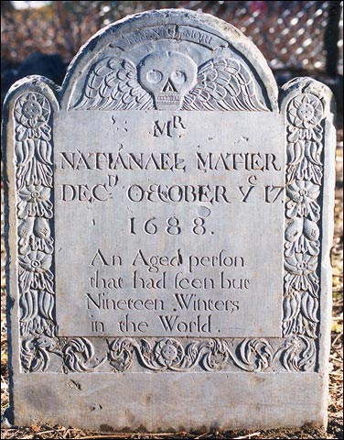
Slate Gravestone for Nathanael Mather, 1688, Charter Street Burial Ground, Salem.
An Aged person / that had seen but / Nineteen Winters / in the World. Hawthorne, a frequent visitor to Salem's Charter Street burial ground, used the epitaph for Nathanael Mather, the son of Rev. Increase Mather,in his story Fanshawe. Historian Sidney Perley wrote the following about Mather: “Nathaniel Mather was son of Rev. Increase and Maria Mather of Boston, where he was born July 6, 1669. His father was president of Harvard College; and two of his brothers were Reverends Cotton and Samuel Mather. He entered Harvard at the age of twelve, and took his first degree at the age of sixteen, when he gave a Hebrew oration, so great a scholar had he become at that tender age. His acquaintance with general literature and science of those times was extraordinary; and he excelled in mathematics, classics and theology. He was a hard student and a good scholar, but too close application, probably without relaxation, produced ill health. At the age of fourteen, he dedicated himself to God. His dedication consisted of devotion to prayer for personal sanctity, and he deliberated so much and so seriously that had became morbid and melancholy. He had taken his second degree at college just before his death. He had contracted ill habits of posture of body, which, persisted in, produced effects which made him appear like an old man. He died in Salem Oct. 17, 1688, at the age of nineteen, and was buried in the Charter Street burying ground, where his gravestone still stands. It is said that his brother Cotton wrote the epitaph upon it….“ (Sidney Perley, The History of Salem, Massachusetts, Vol. 3, pp. 231-32.)
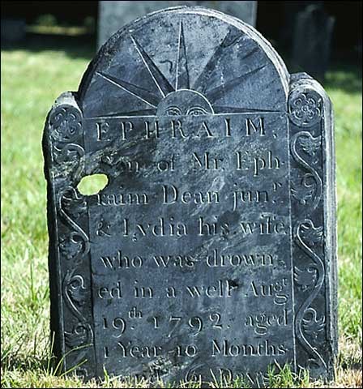
Slate Gravestone for Ephraim Dean, 1792, Attleboro, Massachusetts.

The epitaph on this stone tells us that Ephraim Dean, "drowned in a well August 19th, 1792, aged 1 year, 10 months, and 6 days."
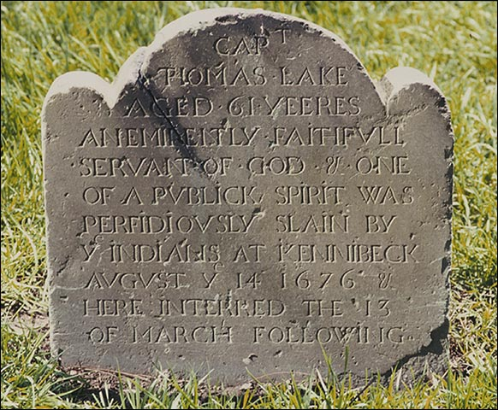
Gravestone of Capt. Thomas Lake, 1676, Copp's Hill Burial Ground, Boston.

Capt. Thomas Lake, who was "perfidiously slain by ye Indians at Kennibeck, August ye 14, 1676."

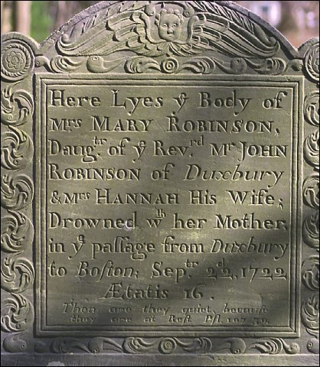
Gravestone of Mary Robinson, 1722, Duxbury, Massachusetts.

The epitaph tells the story of Mary Robinson, who drowned at the age of sixteen, along with her mother. The complete quotation from Psalm 107 reads: "Then are they quiet, because they are at Rest; so He guides them to their desired haven."

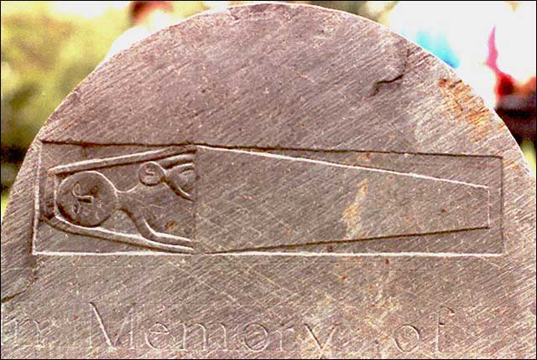
Gravestone for Mary Harvey and Child, 1785, Deerfield, Massachusetts.

In Memory of Mary the Wife of Simeon Harvey, Who Departed this Life December 20th 1785 In 39th year of Her age. On her left Arm lieth the Infant Which was still born.
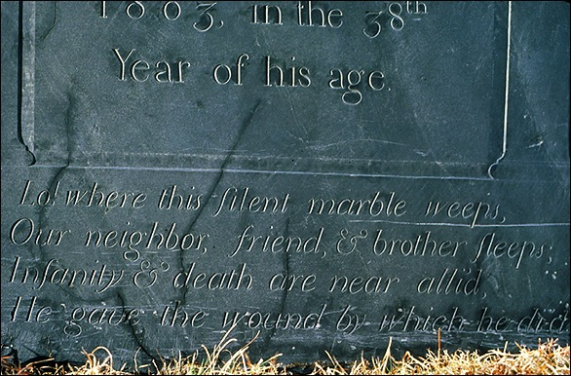
Detail of the Nathan Cutting Stone, 1803, Westminster, Massachusetts.

The epitaph from the Nathan Cutting Stone reads: Lo, Where this silent marble weeps. / Our neighbor, friend and brother sleeps; / Insanity and death are near alli[e]d, / He gave the wound by which he di[e]d.
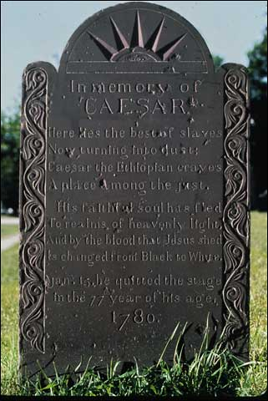
"Caesar the Ethiopian" 1780.

This well-known gravestone in North Attleboro, Massachusetts is for a slave named "Caesar." The epitaph reads: "Here lies the best of slaves, now turning into dust; / Caesar, the Ethiopian, craves a place among the just. / His faithful soul has fled to realms of heavenly light, / And by the blood that Jesus shed, is changed from black to white."
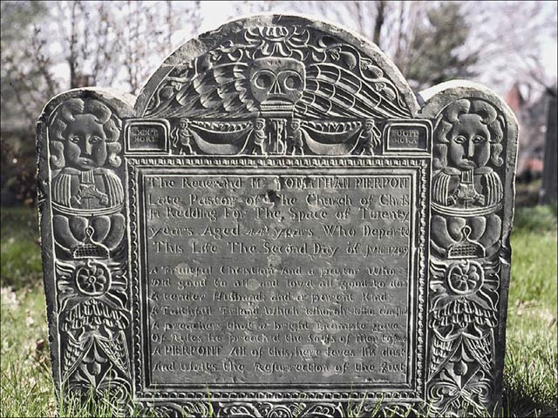
Gravestone of Rev. Jonathan Pierpont, 1709, Wakefield, Massachusetts.

The Pierpont gravestone illustrates superbly the folk art quality of early New England gravestones. The slate stone has two stylized portrait effigies of the minister and was carved by either Joseph or Nathaniel Lamson of Charlestown, Massachusetts. The epitaph reads: A Fruitful Christian, And a pastor who/ Did good to all and lov'd all good to do,/ A tender Husband and a parent Kind/ A Faithful Friend which who oh who can find/ A Preacher that a bright example gave/ Of Rules he preached the souls of Men to save./ A Pierpont all of this here leaves his dust/ And waits the Resurrection of the Just.
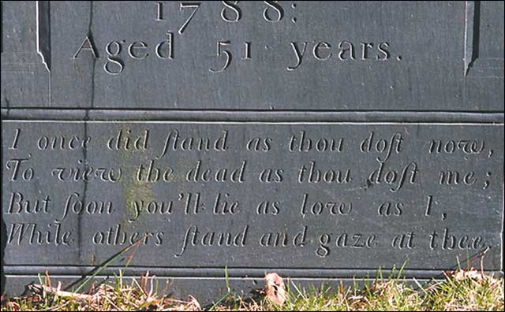
Gravestone Epitaph, 1788.

An epitaph from a gravestone in the Milton Cemetery, Milton, Massachusetts. I once did stand as thou dost now, / To view the dead as thou dost me; / But soon you'll lie as low as I, / While others stand and gaze at thee.
Now, create an epitaph for Young Goodman Brown. If it had not been left blank, what should it have said?

